|  |
| --- |
| Albert’s inc. games |
| BROSKI |
| Be Like Bro |
| Version 1.1  All work Copyright © 2016 by Albert’s Inc. Games.  All rights reserved. |
| **Albert Monteiro**  **Bhanu Kaplish**  **Lovepreet Ralh** |
|  |



|  |
| --- |
| Apr 08, 2016 |

**Table of Contents**

Version History…………………………………………………………………………………………………………………………4

Game Overview…………………………………………………………………………………………………………………………5

Game Play Mechanics……………………………………………………………………………………………………………….5

Camera…………..…………………………………………………………………………………………………………………………5

Controls…………………………………………………………………………………………………………………….………………5

Saving and Loading……………………………………………………………………………………………………………………5

Interface Sketch…………………………………………………………………………………………………………………...…6,7

Menu and Screen Description…………………………………………………………………………………………………..7

Game World……………………………………………………………………………………………………………………………..7

Levels………………………………………………………………………………………………………………………………………..7

Game Progression…………………………………………………………………………….………………………………………8

Characters………………………………………………………………………………………………………………………………..8

Non-player Characters……………………………………………………………………………………………………………..8

Enemies……………………………………………………………………………………………………………………………………8

Weapons………………………………………………………………………………………………………………………………….8

Items…………………………………………………………………………………………………………………………….………….8

Abilities…………………………………………………………………………………….………………………………………………8

Vehicles……………………………………………………………………………………….……………………………………………8

Script……….………………………………………………………………………………….……………………………………………8

Scoring…….………………………………………………………………………………….……………………………………………9

Puzzles/Mini-games………………………………………………………………………………….………………………………9

Bonuses…..………………………………………………………………………………….……………………………………………9

Cheat Codes……………….……………………………………………………………….……………………………………………9

Sound Index……………………………………………………………………………………………………………………………..9

Story Index……………………………………………………………………………………………………………………………….9

Art/Multimedia Index………………………………………………………………….…………………………………………10

Design Notes……………………………………………………………………………….…………………………………………10

Future Features……………………………………………………………………………………..…………………....…………10

Links..............................................................................................................................................10

**Version History**

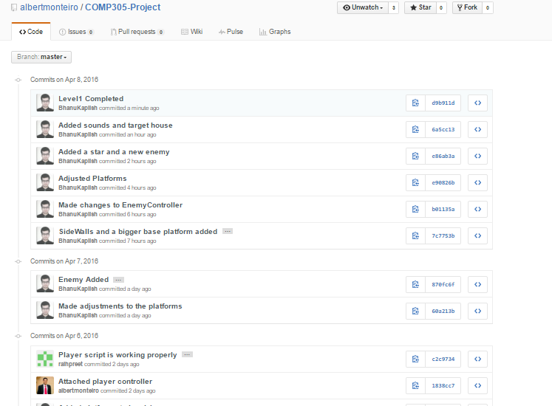

1. **Game Overview**

The goal of the game is to reach the house by collecting stars for earning points while restraining from Cutman, the enemy.

1. **Game Play Mechanics**

This game has both arrow key i.e. up, down, left and right and use the standard keys (WASD) for moving the player i.e. Jack.

1. **Camera**

The camera follows the player.

1. **Controls**

Use the direction and the standard keys (WASD) keys on the keyboard to control the player.

1. **Saving and Loading**

N/A

1. **Interface Sketch**

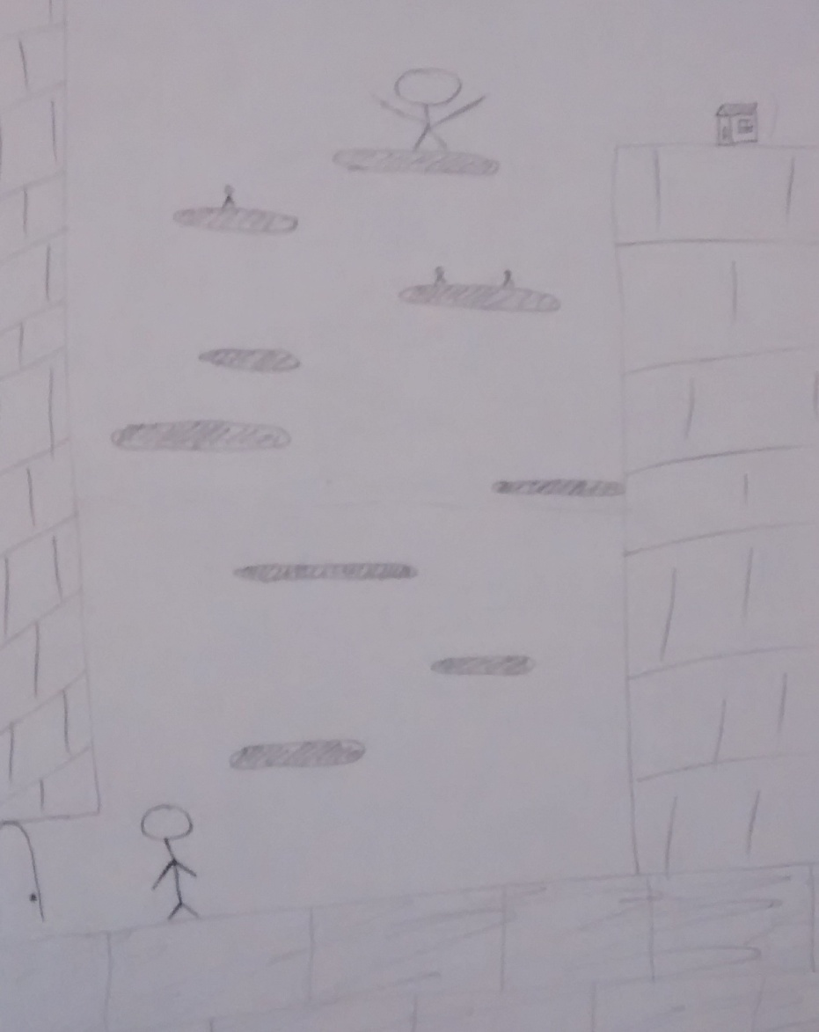

**Level 1**

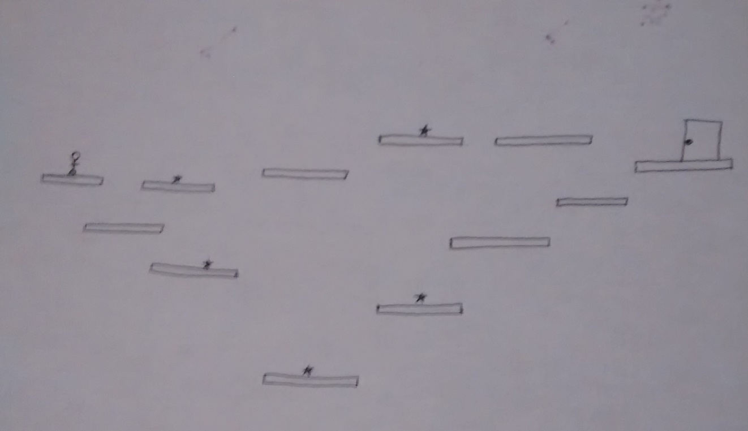

**Level 2**

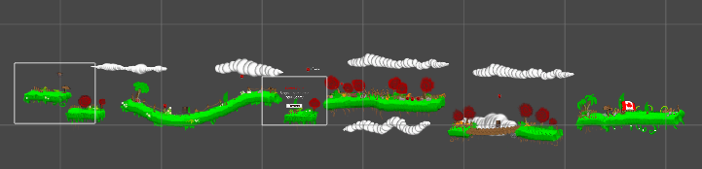

**Level 3**

1. **Menu and Screen Descriptions**

N/A

1. **Game World**

This is a bottom-up 2D platform game, where the player has to reac the top while collecting stars and preventing the enemies i.e. Cutmans

1. **Levels**

N/A

1. **Game Progression**

N/A

1. **Characters**

This game has two characters i.e. Jack (the player) and Cutman (enemy)

1. **Non-player Characters**

Stars for collecting points

1. **Enemies**

Cutman is the enemy in this game which is animated.

1. **Weapons**

N/A

1. **Items**

The enemies must be avoided or the player will lose lives.

1. **Abilities**

Move around and jump.

1. **Vehicles**

N/A

1. **Script**

This game has C# scripts like GameController.cs and HeroControllerScript.cs.

1. **Scoring**

You collect the stars to gain points which are multiples of 100.

1. **Puzzles/Mini-games**

N/A

1. **Bonuses**

TBD

1. **Cheat Codes**

N/A

1. **Sound Index**

|  |  |  |
| --- | --- | --- |
| **Name** | **Author** | **Source** |
| BackgroundMusic.ogg | [Iwan](https://www.youtube.com/channel/UCGy7ppDyzQ4JX9WsSfkN6ow) Sounds and DIY | Youtube |
| Level1GameOver.ogg | [Iwan](https://www.youtube.com/channel/UCGy7ppDyzQ4JX9WsSfkN6ow) Sounds and DIY | Youtube |
| CutmanHurt.ogg | [Iwan](https://www.youtube.com/channel/UCGy7ppDyzQ4JX9WsSfkN6ow) Sounds and DIY | Youtube |
| Star.ogg | [Iwan](https://www.youtube.com/channel/UCGy7ppDyzQ4JX9WsSfkN6ow) Sounds and DIY | Youtube |

1. **Story Index**

The player has to climb the platforms to reach his house while collecting stars as trophies. He has to stay away from Cutman, the bad guy of this game, because he takes away one life from the player as soon as the player collides with it.

1. **Art / Multimedia Index**

|  |  |  |
| --- | --- | --- |
| **Name** | **Image Preview** | **Source** |
| pokemon_house.png |  | Google images |
| Platform.png |  | Google images |
| background2.png |  | Google images |
| SmallerPlatform.png |  | Google images |
| side_wall.png |  | Google images |
| Balans-Normal.ttf |  | junkohanhero.1001fonts.com |

1. **Design Notes**

N/A

1. **Future Features**

I want to add moving monsters to the game which will be falling from the top.

1. **Links**

Github: <https://github.com/albertmonteiro/COMP305-Project>